Chapter 19, Solution 99

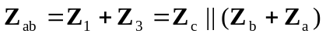
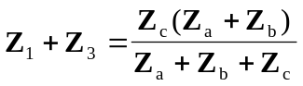 (1)

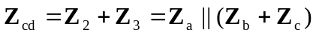
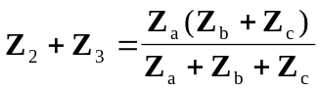 (2)

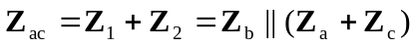
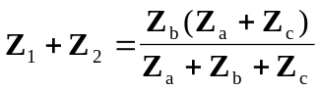 (3)

Subtracting (2) from (1),
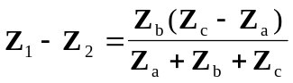 (4)

Adding (3) and (4),
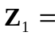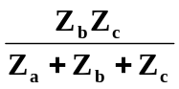 (5)

Subtracting (5) from (3),
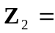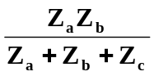 (6)

Subtracting (5) from (1),
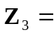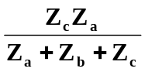 (7)

Using (5) to (7)
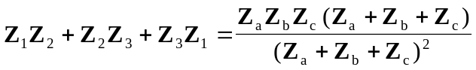
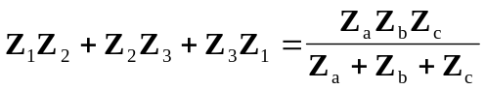 (8)

Dividing (8) by each of (5), (6), and (7),
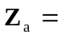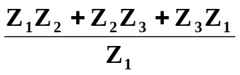

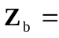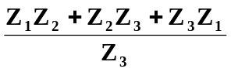

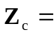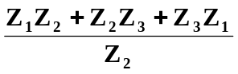

as required. Note that the formulas above are not exactly the same as those in Chapter 9 because the locations of 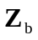 and 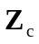 are interchanged in Fig. 18.122.

